**Ideation Phase**

**Define the Problem Statements**

|  |  |
| --- | --- |
| Date | 16 October 2022 |
| Team ID | PNT2022TMID28837 |
| Project Name | Smart Waste Management System for Metropolitan cities |
| Maximum Marks | 2 Marks |

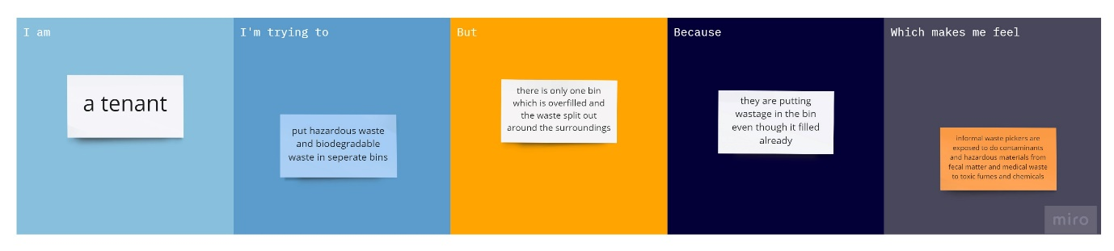

|  |  |  |  |  |  |
| --- | --- | --- | --- | --- | --- |
| **Problem Statement (PS)** | **I am (Customer)** | **I’m trying to** | **But** | **Because** | **Which makes me feel** |
| PS-1 | Fruit vendor (near the dump yard) | Report to municipal corporation for open burning of hazardous waste | There are not taking any necessary actions | Inactive and negligible municipality members | Landfills, considered the last resort in the waste hierarchy leads to release of hazardous gases which effect the waste workers or other people involved in waste burning and community members while leads to health problems |
| PS-2 | A citizen | Dump the waste in the closed dust bins | Due to overfill of waste materials these waste spread all over the surroundings | Improper management of dust bins by municipality | Poorly managed waste often ends up in ponds , reservoirs or drainage systems which leads to diseases like malaria, cholera etc,. |